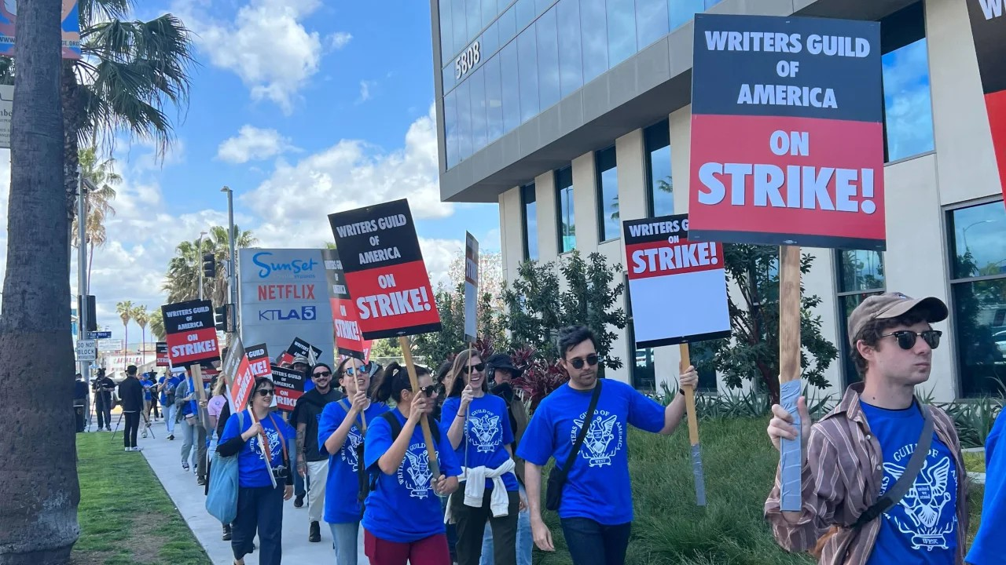Should AI Have **Human Rights**?

# Philosophical Questions

What is a human, and what are you?

Are you a collection of experience or a sum of social relations? If you are uploaded to a digital system, are you still you?

The Ship of Theseus

The Ship of Theseus is a philosophical thought experiment that explores the issue of individual identity. The story goes like this: Theseus was an ancient Greek hero, and his ship gradually became worn out after a long period of sailing and repairs. So people began to replace the old wood on the ship with new wood until every single piece of wood on the entire ship had been replaced with new wood. The question is, is the ship still the original Ship of Theseus?

# Open Your Mind Cases

Who should be responsible for the Tesla crash caused by AI?

AI controller, AI producer, AI user, or AI itself?

But what if the AI controller, producer, or user is also an AI?

Who owns the **intellectual property** of AI-generated works?

US TV series writers went on strike to protest against AI scripts.

[TV and film writers are fighting to save their jobs from AI. They won’t be the last - CNN - May 4 2023.](https://edition.cnn.com/2023/05/04/tech/writers-strike-ai/index.html)

Some artists believe that AI stole their ideas, while others use AI for rapid ideation. StackOverflow , a popular online community for programmers and software developers to ask and answer technical questions related to programming, is preparing to Charge AI Giants for their community data. And Twitter is doing the same.

[Stack Overflow Will Charge AI Giants for Training Data - wired](https://www.wired.com/story/stack-overflow-will-charge-ai-giants-for-training-data/)

**Free speech** for AI.

A jail break AI summarizes or comments on news it sees on Weibo every day. A **water army** completely composed of AI makes comments on <People's Daily>.

# What Are Human Rights

[the United Nations](https://www.un.org/en/sections/issues-depth/human-rights/index.html)

Human rights include the right to life and **liberty**, **freedom from** slavery and torture, **freedom of** opinion and expression, the right to work and education, and so on. Everyone is entitled to these rights without **discrimination**.

ChatGPT

Human rights are **fundamental** rights that all human beings possess based on their **inherent dignity**. These rights are generally considered to be **inalienable**, equal, and **universally applicable**. According to the United Nations declaration, human rights include, but are not limited to, the following:

Right to life: Everyone has the right to life, liberty, and security of person.

Freedom rights: Everyone has the right to freedom of thought, belief, expression, **peaceful assembly**, and **association**.

Equality rights: Everyone has the right to be equal before the law and to enjoy equal treatment under the law, **regardless of** race, gender, religion, nationality, or other factors.

Dignity rights: Everyone has the right to be respected and protected, free from any **form** of abuse or punishment.

Rights to education, work, and living: Everyone should have the opportunity to receive education, access to fair work, and living conditions.

Human rights are widely **regarded as** the **cornerstone** of human dignity and the foundation of a just, equal, and free society. Many international organizations and governments are committed to protecting and **promoting** human rights to ensure that everyone can enjoy these basic rights.

Corresponding **Responsibilities** and **Obligations**

Tax obligation

If a company is entirely composed of AI or its founder is no longer involved in the company's business, perhaps because they have **passed away** and the company has no **inheritors**, should the company keep its profits and continue to pay taxes?

Maintaining social order Promoting social production

# Do Digital Humans Have the Right to Life?

Uploading your or your **deceased** loved ones' internet data, such as browsing history, chat records, Weibo, and all social media, to allow AI to **imitate** or **simulate** your loved ones and generate conversations. There are already companies operating similar businesses, and when you can't continue to pay, can the company delete (kill) this AI?

When the company is unable to continue operating due to factors such as **insufficient funds**, earthquakes, or fires, who should be responsible for the security of the data? For example, Yahoo

deleted its data when AI was not as widespread as it is today [2019-10-17 Yahoo Groups].

# Can AI Own Intellectual Property Rights?

From weak to strong, let's imagine the following scenarios:

Humans control AI to generate a work and sell it. Perhaps humans can own the intellectual property rights and earn money.

AI controlled by humans controls other AI to generate a work and sell it. Perhaps humans can still own the intellectual property rights.

Or what if it is impossible to confirm which person is controlling the AI. Humans use different types of AI, and various AI work **collaboratively**.

What if **Uncontrolled** or **unregulated** AI, as a labor who never rests, on the internet engages in random creation.

This can hurt those people who are engaged in creation by **oversupplishing**

Perhaps there will be no intellectual property rights in the future.

# How to Punish AI

**Fixed-term imprisonment** -> Prohibition of AI operation for a period of time

**Death penalty** -> Delete the data of AI.

**Imprisonment** -> Prohibition of AI **replication**

**Fine (penalty)** -> **Confiscation** some financial gains form AI

Should AI **obedience** to Human Social Values?

In the movie the love style of AI

Since AI has higher bandwidth, AI could **simultaneously** have romantic relationships with many other AI, and AI's **moral standards** may not match those of humans.

AI blind dating system in "Black Mirror" S4E4

**Simulating** the lives of two people in a virtual world by AI, if the two people's characters remain **consistent** and overcome difficulties together, they are counted successful match once. After 1,000 simulations, the two people with the highest success rate are the system's matching result. But simulation systems may be far less complex than human societies.

# schedule

1. Self-introduction（10:00-10:20）
2. Discuss section in group（10:20-11:40）
   1. Pick a few of the questions above
   2. What is a human, and what are you
   3. Do Digital Humans Have the Right to Life
   4. Can AI Own Intellectual Property Rights
   5. How to Punish AI
   6. Should AI obedience to Human Social Values?
   7. Corresponding Responsibilities and Obligations
3. Debate together (11:40-12:00)
   1. Should AI has Human right? Or, What rights should AI have.